SUBHIKSHA L

1BM24CS292

Queries:
1. List employees with their department name & location
select e.ename, a.dname,a.dloc
from employee e, dept a
where e.deptno=a.deptno;
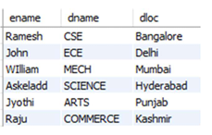
2. Employees who are not assigned to any project
select ename
from employee e
where empno not in(select empno from assigned_to);
3. Project-wise headcount of employee
select p.pname, count(a.empno) as total_employees
from project p, assigned_to a
where p.pno=a.pno
group by p.pname;
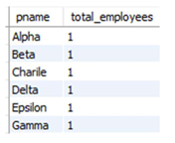
4. Department-wise average & max salary
select d.dname, avg(e.sal) as average_salary,max(e.sal) as max_salary
from employee e, dept d
where e.deptno=d.deptno
group by d.dname;
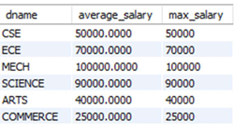
5. Total incentives earned by each employee (lifetime)
select e.ename, i.empno, sum(i.incentive_amt) as total_incentives
from employee e, incentives i
where e.empno=i.empno
group by e.empno;
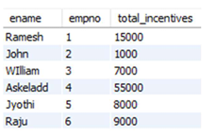
6. Employees working on a given project (project name :Alpha Project)
select p.pname, e.ename
from employee e, project p, assigned_to a
where e.empno=a.empno and a.pno=p.pno and p.pname="Alpha";
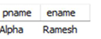
7. Departments with no employees
select dname
from dept
where deptno not in (select deptno from employee);
8. Managers and their direct report counts (MGR_NO references EMPNO)
select e.mgr_no, count(e.empno)
from assigned_to a, employee e
where e.empno=a.empno
group by e.mgr_no;
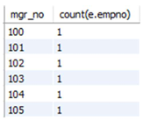
9. Employees assigned to more than one project.
select e.empno,e.ename
from employee e, project p, assigned_to a
where e.empno=a.empno and p.pno=a.pno
group by e.empno
having count(p.pno)>1;

